Stable High Energy, High Repetition Rate Frequency Doubling in Large Aperture Temperarue Controlled LBO at 515 nm
Jonathan P Phillips¹*, Saumyabrata Banerjee¹, Klaus Ertel¹, Paul Mason¹, Jodie Smith¹, Thomas Butcher¹, Mariastefania De Vido¹, Chris Edwards¹, Cristina Hernandez-Gomez¹ and John Collier¹
¹ Science and Technology Facility Council, Rutherford Appleton Laboratory, Harwell Campus, Didcot, OX11 0QX, United Kingdom
* Corresponding author: jonathan.phillips@stfc.ac.uk
Received XX Month XXXX; revised XX Month, XXXX; accepted XX Month XXXX; posted XX Month XXXX (Doc. ID XXXXX); published XX Month XXXX

We report on frequency doubling of high energy, high repetition rate ns pulses from a cryogenically gas cooled, multi-slab Yb:YAG laser system, using type-I phase-matched LBO crystal. Pulse energy of 4.3 J was extracted at 515 nm for a fundamental input of 5.5 J at 10Hz, corresponding to a conversion efficiency of ~77%. However, during long-term operation, a significant reduction of efficiency (more than 25%) was observed owing to the phase-mismatch arising due to the temperature dependent refractive index change in the crystal. This forced frequent angle-tuning of the crystal to recover the SHG energy. A five-fold improvement in energy stability of SHG was observed with a temperature controlled LBO crystal at temperatures > 27 °C. Additionally, detailed analysis and temperature profiles are also presented. © 2019 Optical Society of America
http://dx.doi.org/10.1364/OL.99.099999
Long-term energy stability of a laser is an essential parameter for a facility-worthy laser system. New generation laser facilities will not only offer ultra-high intensity pulses, but also high repetition rate for exploring the entire parameter space for an experiment. Applications include laser particle acceleration, active real time imaging and medical therapies [1-3]. Ultra-high intensity femtosecond (fs) laser systems used in such facilities rely on high energy nanosecond (ns) pump lasers operating in the green spectrum, at wavelengths near 500 nm, at high pulse repetition rate (~10Hz) and therefore high average power [4]. These green pulses coincide with the peak in the absorption spectrum of Ti:sapphire [5], or can be used to pump optical parametric chirped pulse amplifiers (OPCPA)[6].
Rare-earth doped solid state laser materials, which are at present the most efficient sources for ns high energy pulses, operates at the wavelengths near 1 µm, and thus are not suitable for pumping ultra-high intensity fs lasers. Nonlinear frequency up-conversion of such ns high energy lasers to green wavelength is the key step in making suitable pumps for ultra-short fs laser.
In a previous publication [7] we have demonstrated a cryogenically gas cooled diode pumped solid state laser (DPSSL) prototype amplifier system (named DiPOLE) generating pulse energies of 10.8 J, 10 ns at 10 Hz. More recently at the Central Laser Facility (CLF), we have demonstrated a higher energy DPSSL based on DiPOLE technology that produces 100 J, 10 Hz ns pulses [8] confirming the scalability of the technology. Further to this, type - I
second harmonic generation (SHG) of the DiPOLE laser was demonstrated in DKDP, LBO and YCOB [9] and LBO was found to be the most suitable and efficient owing to its temperature and angular bandwidth for the SHG process.
In this paper, we characterise the long-term energy stability of the type-I SHG process in LBO crystal at 5.5 J and 10 Hz operation. Although, initially high conversion efficiency of ~77% was observed for type-I SHG, the residual absorption of the LBO crystal at 1030nm and 515nm contributed to the increase of the crystal temperature. Further, temperature dependent change in the refractive index contributed to the phase-mismatch for the type-I SHG process and deteriorated the conversion efficiency by time. One alternative to recover the SHG energy is to frequently re-tune the angle of the crystal which makes the system complicated and prone to errors if an automatic setup is adopted for re-tuning.
We propose and demonstrate a simple method of controlling the temperature of the crystal to achieve long-term energy stability of the type-I SHG process in LBO. The experimental setup used is shown in Figure1.
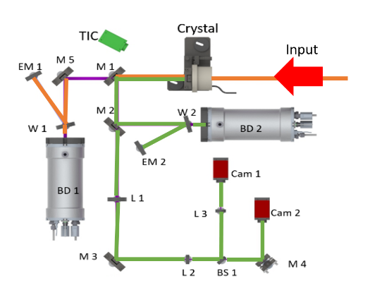
Fig. 1 Schematic of the experimental setup for frequency doubling stability experiments on LBO. M1-M2 dichroic mirrors (HR@515 nm, HT@1030 nm); W1 uncoated wedge (wedge angle 30 arcmin); M4 mirror (HR@515 nm); M5 mirror (HR@1030 nm) ; BS1 beamsplitter (50:50@515 nm); W2, W3 wedges (fused silica wedge angle 30 arcmin); Cam 1, Cam 2 CCD cameras; EM1, EM2 energy meters; BD1, BD2 beam dumps; L1 (f=500 mm), L2 (f=150 mm) and L3 (f =100 mm) Lenses. TIC is a thermal imaging camera.

The LBO crystal (Cristal Laser, France) was 30 mm in diameter and 13 mm thick, and was cut with a theta angle of 90 degrees and a phi angle of 13.6 degrees for type-I phase matching. To minimize surface reflections both crystal faces were coated with a dual-band anti-reflection (DBAR) coating for 1030 nm and 515 nm. The linear absorption of LBO at 1064 nm is reported as 15 ppm/cm and 20 ppm/cm at 532 [10] and a similar value is expected at 1030 nm.
The input beam size is 1 cm square entering the SHG crystal. The unconverted 1030 nm beam was transmitted through M1 and reflected from M5 into a beam dump (BD1). A wedge (W1) was positioned in front of the beam dump which reflects ~4% of the residual beam onto a calibrated energy meter EM1 (Gentec QE50LP-S-MB). The generated 515 nm beam was reflected off M1 and M2 into a second beam dump (BD2). A second wedge (W2) before the beam dump reflects ~4% onto another calibrated energy meter EM2 (QE50LP-S-MB) to measure 515 nm energy. Leakage of the 515 nm beam through M2 is reduced in size to a 3.5 mm by a telescope (L1 & L2) with an uncoated wedge (M3) placed between the lenses to reduce energy. The smaller beam is reflected from a 50:50 non-polarizing beam splitter (BS) and focused onto a CCD camera (CAM 1) by lens L3 to obtain a far-field image. The beam transmitted through the BS is directed onto a second camera (CAM 2) by mirror (M4) to obtain a near-field image. Colored-glass spectral filters were located in front of the photodiode and both CCD cameras to block any residual 1030 nm (FEL1000). A Thermal imaging camera ( FLIR A6700 ) is pointed at the crystal to record its surface temperature.
The experiment to measure long-term stability was conducted in two phases. In phase one the LBO crystal was held in a thermally isolated holder with minimal thermal contact with the surroundings, except through free convection. There was no attempt in this case to actively cool or heat the crystal to control its temperature. A thermal imaging camera was used to record the surface temperature of the crystal at the center of the beam in the crystal. In the second phase the LBO crystal was mounted in a temperature-controlled holder in which a heater coil could raise the temperature up to 100°C and stabilize it to ±0.1°C. A spring mechanism provided good thermal contact between the cylinder face of the crystal and the heater element, which was thermally insulated from the surroundings by a plastic cover. The flat faces of the crystal were open to the ambient air.
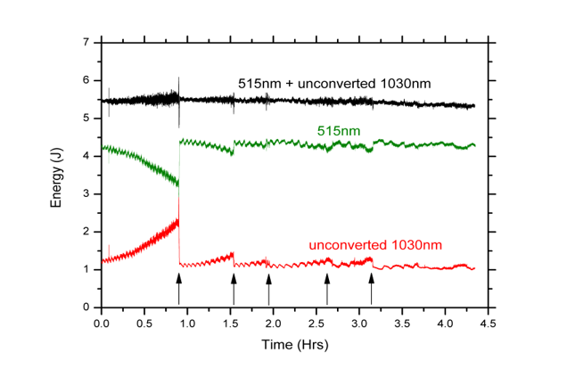
Fig. 2 Type-I phase matching frequency converted energy for LBO with a 1 cm² beam. Black line shows total energy, Green line shows frequency converted energy, Grey line shows the unconverted fundamental. The arrows indicate the change of angle (Theta) of the crystal to restore the energy in the SHG.
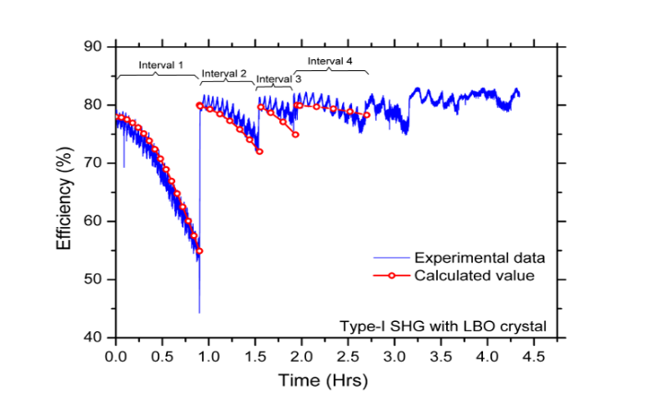
Fig. 3 Efficiency of frequency conversion in LBO with a thermally isolated holder versus time. The solid (blue) curve shows the experimental data and the dotted (red) line shows the calculated curve. Intervals are defined after which angle tuning was utilized to recover the SHG energy.
Figure 2 shows the measured frequency conversion performance without temperature stabilization over a 4 hour period. Here the LBO was held in a thermal isolated holder. The absorption induced heating effect becomes evident, significantly reducing the conversion efficiency. The corresponding conversion efficiency is shown in Figure 3. Over the first hour of the experiment the efficiency falls from 77% to 52% as the crystal temperature rises from 21.2°C to 22.7°C (ΔT=1.5°C). This was compensated for by changing the angle (theta) of the crystal. This was repeated several times during the experiment the exact timing is indicated on the graph by the use of arrows in Figure 2.
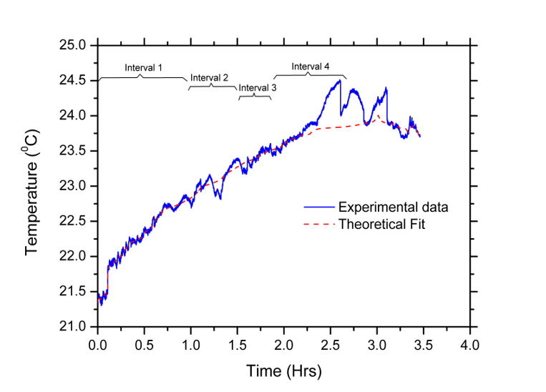
Fig. 4 Temperature measurements of the center of the crystal at the surface during the long run with the thermal isolated crystal holder versus time. The experimental data is a blue line and the theoretical fit is described by a red line. There are four intervals marked indicating the times when the calculated curves match the efficiency curve in Fig. 3, related to the temperature changes in the refractive index. The temperature rate of change of each interval was noted and then used to calculate the theoretical curves shown in Fig. 3.

We calculated the loss in efficiency by using the Sinc² function due to temperature difference in the crystal vs time. In interval 1, efficiency dropped from 77% to 52% with a temperature increase of 1.55 °C. The calculated values show good agreement with the experimental rate of change in temperature, as shown in Figure 4. Also shown in Figure 4 are Intervals 2, 3 and 4 calculated using the Sinc² function. They had respective temperature slopes of 0.6, 0.5 and 0.5, the theoretically calculated values agree reasonably well.

In phase 2 of the experiment, the LBO crystal was placed in a temperature controlled oven set to 27°C (The temperature of the crystal was observed to be 26 °C) and the efficiency of the crystal was observed over > 2.5 hours as shown in Fig 5. After two hours of operation, the efficiency dropped by < 5 %; at this point we changed the angle of the crystal to confirm that the SHG energy could be recovered. Compared to drop in efficiency observed in a thermally isolated case (phase 1 experiments), this is a 5-fold improvement in long-term stability of SHG process in type-I LBO crystal.
Figure 6, shows the near and far field images of the SHG signal. For a 100 mm focal length lens, the far-field spot diameter (1/e) was 44.7 μm in X-axis and 61.8 μm in the Y-axis, this corresponds to 2.0 and 2.8 times the diffraction limit. We note that the SHG far-field could be optimized by the introduction of an adaptive optics mirror in the amplifier system. No optical damage was observed to the crystal or its coating when operated at these elevated temperatures.

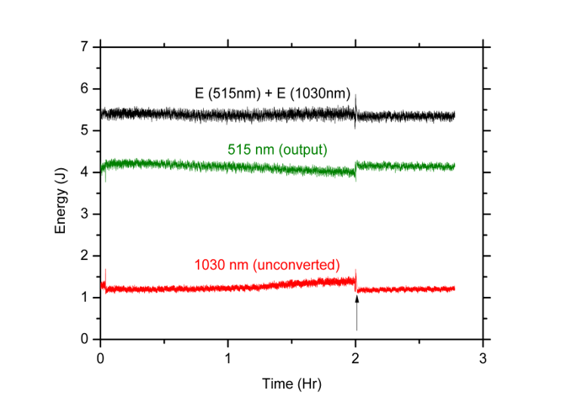
Fig 5 Experiment with temperature set to 27ºC for the crystal showing the total energy at 5.4 J, black line for the fundamental and frequency converted energy, the green line is for frequency converted energy at 4.1 J and the red line is for the unconverted fundamental at 1.1 J.

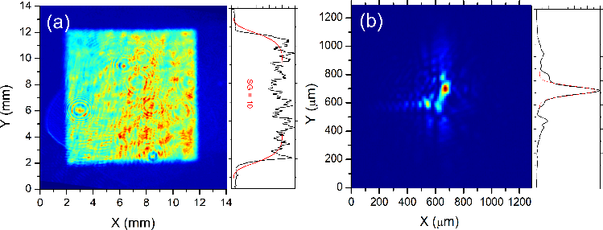
Fig. 6 Near-field and far-field profiles for 515 nm output. (SG = Super Gaussian)
In a separate experiment, the input beam (1030nm) size was increased to 1.4 cm by 1.4 cm and the LBO oven crystal temperature was increased to 35 °C to confirm stable operation at higher average power (70 W) operation and at a higher crystal temperature. A temperature difference of 0.5 °C was recorded between the center and the edge of the crystal inside the oven at 35 °C. Owing to the reduced energy density of 3.5 J/cm², maximum conversion efficiency of 64% was recorded for the experiment (compared to 77% for the previous experiment). Figure 7, shows the long-term energy stability of the SHG process for this setup at higher input average power. For a period of 45 mins of operation, the SHG energy stability was 0.8% RMS. This is an improvement by a factor of 8 in long-term energy stability compared to the experiment done with a thermally isolated LBO crystal for the same period of time.
It should be noted that for a large aperture crystal (60mm x 60mm) used for frequency conversion of a 100J-level laser, the temperature difference between the center and the edge might be greater than the acceptance temperature bandwidth for LBO (ΔT.l = 4.2k) and can contribute to loss in efficiency. Thus a careful design of the oven is required for large aperture SHG crystal, if a temperature controlled approach is used for long-term energy stability.

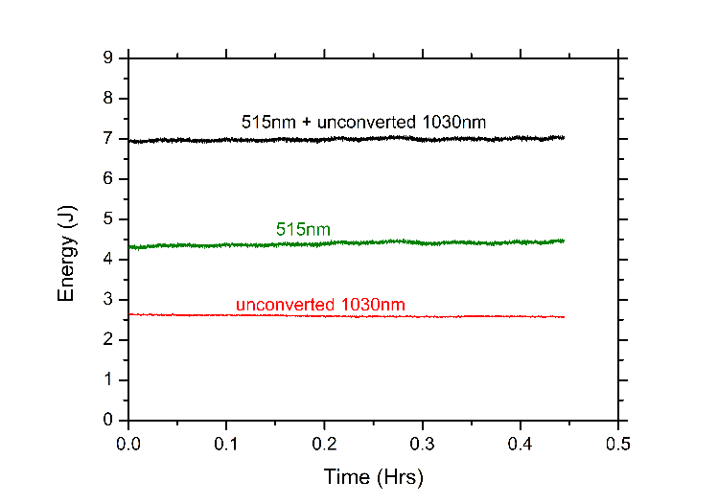
Fig. 7 Experiment with temperature set to 35ºC for the crystal showing a total energy at 7 J, black line for the fundamental and frequency converted energy, the green line is for frequency converted energy at 4.4 J and the red line is for the fundamental at 2.8 J.
In summary, we successfully demonstrate significant improvement of second harmonic energy stability for a long-term operation via elevating and controlling temperature of the SHG crystal (LBO in our experiment). The requirement of frequent angle tuning to recover SHG energy due to the phase-mismatch arising due to the temperature dependent refractive index change in the crystal for high average power operation can be mitigated by the proposed method.

Funding. United Kingdom Research and Innovation (UKRI)

Acknowledgment. This project has received funding from the European Union’s Horizon 2020 research and innovation programme under grant agreement No. 739573.

Disclosures. The authors declare no conflicts of interest.
References

- F Amiranoffy, A Antonettiz, P Audeberty, D Bernardx, B Crosk, F Dorchiesy, J C Gauthiery, J P Geindrey, G Grillonz, F Jacquetx, G Matthieussentk, J R Marqu`esy, P Min´ex, P Mora, A ModenaC, J Morillo, F Mouliny, Z Najmudinc, A E Speckaz and C Stenz, “Laser particle acceleration: beat-wave and wakefield experiments,” Plasma Phys. Control Fusion 38, A295-300, (1996).
- M. H. Key, “Laboratory production of X-ray lasers”, Nature, 316, 314-319, (1985).
- Masood, M.Bussman, T.E. Cowan, W. Enghardt, L. Karsch, F. Knoll, U. Schramm, J. Pawelke, “A compact solution for ion beam therapy with laser accelerated protons,” Appl. Phys. B 117, 41-52, (2014).
- Extreme Light Infrastructure (ELI) Beamlines Facility, Prague, Czech Republic www.eli-beams.eu
- M. Somekh, Jean Paul Chambaret, G. Mouro, “The APOLLON/ ILE 10PW Laser Project”, Presented at ELI- Nuclear Physics Meeting, Bucharest, 1-2 Feb. 2010.
- O. Chekhlov, J.L Collier, I N Ross, P. Bates, M. Notely, W. Shaikh, C.N Danson, D. Neely, P. Matousek, S. Hancock “High Energy broadband ultrashort pulse OPCPA system, ” CLF Annual report (2004-2005).
- S. Banerjee, K. Ertel, P. D. Mason, P. J. Phillips, M. De Vido, J. M. Smith ,T. J. Butcher, C. Hernandez-Gomez, R. Justin S. Greenhalgh and J L. Collier,”DiPOLE: a 10 J, 10 Hz cryogenic gas cooled multi-slab nanosecond Yb:Yag laser”, Optics Express 23., 15 (2015)
- P. D. Mason, M.Divocky, K. Ertel, J. Pillar, T. J. Butcher, M.Hanus, S. Banerjee, P. J. Phillips, J. M. Smith ,M. De Vido, S. Tomlinson, O. Chekhlov, W. Shaikh, S. Blake, P. Holligan, L. Antonio, C. Hernandez-Gomez, and J. L. Collier, “Kilowatt average power 100 J-level diode pumped solid state laser”, Optica 4(4) 438 (2017)
- J.P. Phillips, S. Banerjee, M. Fitton, T. Davenne, J. Smith, K. Ertel, P. Mason, T. Butcher, M De Vido, J. Greenhalgh, C. Edwards, C.Hernandez-Gomez and J. Collier, “High energy, high repetition rate, second harmonic generation in large aperture DKDP, YCOB and LBO crystals” Optics Express 24. 17 (2016)
- Cristal Laser private communication and website http://www.cristal-laser.com/UserFiles/File/brochures-techniques/lbo.pdf

